**Aestivial**

**Course: Theory Of Computation**

**Notes**

1. **Context free grammar and Context free language**

Context-Free Language (CFL) is a language which is generated by a context-free grammar or Type 2 grammar(according to Chomsky classification) and gets accepted by a Pushdown Automata.

CFG stands for context-free grammar. It is a formal grammar which is used to generate all possible patterns of strings in a given formal language. Context-free grammar G can be defined by four tuples as:

G = (V, T, P, S)

Where,

G is the grammar, which consists of a set of the production rule. It is used to generate the string of a language.

T is the final set of a terminal symbol. It is denoted by lower case letters.

V is the final set of a non-terminal symbol. It is denoted by capital letters.

P is a set of production rules, which is used for replacing non-terminals symbols(on the left side of the production) in a string with other terminal or non-terminal symbols(on the right side of the production).

S is the start symbol which is used to derive the string. We can derive the string by repeatedly replacing a non-terminal by the right-hand side of the production until all non-terminal have been replaced by terminal symbols.

1. **Leftmost and Rightmost Derivation of a String**

* Leftmost derivation − A leftmost derivation is obtained by applying production to the leftmost variable in each step.
* Rightmost derivation − A rightmost derivation is obtained by applying production to the rightmost variable in each step.

Let’s find out the derivation tree for the string "a+a*a". It has two leftmost derivations.

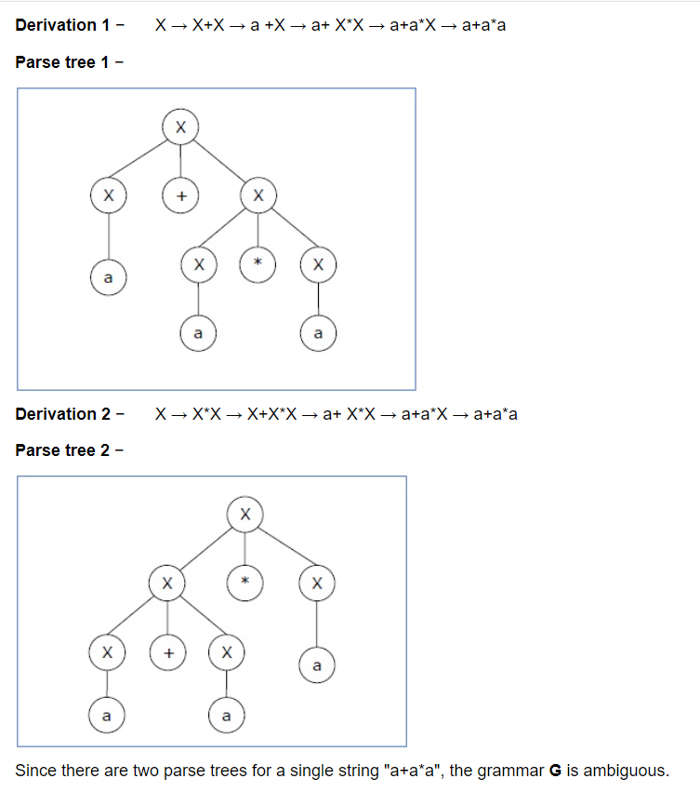

1. **Ambiguity of context free grammar**

If a context free grammar G has more than one derivation tree for some string w ∈ L(G), it is called an ambiguous grammar. There exist multiple right-most or left-most derivations for some string generated from that grammar.

1. **Pushdown Automata (PDA)**

A Pushdown Automata (PDA) can be defined as :

Q is the set of states

∑is the set of input symbols

Γ is the set of pushdown symbols (which can be pushed and popped from stack)

q0 is the initial state

Z is the initial pushdown symbol (which is initially present in stack)

F is the set of final states

δ is a transition function which maps Q x {Σ ∪ ∈} x Γ into Q x Γ*. In a given state, PDA will read input symbol and stack symbol (top of the stack) and move to a new state and change the symbol of stack.

1. **Pumping Lemma for Context Free Grammar**

If L is a context-free language, there is a pumping length p such that any string w ∈ L of length ≥ p can be written as w = uvxyz, where vy ≠ ε, |vxy| ≤ p, and for all i ≥ 0, uvixyiz ∈ L. Pumping lemma is used to check whether a grammar is context free or not. Let us take an example and show how it is checked.

**Q.** Find out whether the language L = {xnynzn | n ≥ 1} is context free or not.

**Ans.**

Let L is context free. Then, L must satisfy pumping lemma.

At first, choose a number n of the pumping lemma. Then, take z as 0n1n2n.

Break z into uvwxy, where

|vwx| ≤ n and vx ≠ ε.

Hence vwx cannot involve both 0s and 2s, since the last 0 and the first 2 are at least (n+1) positions apart. There are two cases −

Case 1 − vwx has no 2s. Then vx has only 0s and 1s. Then uwy, which would have to be in L, has n 2s, but fewer than n 0s or 1s.

Case 2 − vwx has no 0s.

Here contradiction occurs.

Hence, L is not a context-free language.